**ANALYTICS FOR HOSPITAL'S**

# **HEALTH-CARE DATA**

**PROJECT DESIGN PHASE – II**

**CUSTOMER JOURNEY**

|  |  |
| --- | --- |
| **Date** | 16 October 2022 |
| **Team ID** | PNT2022TMID47568 |
| **Project Name** | Analytics for Hospitals’ Health-care data |
| **Maximum Marks** | 4 Marks |

M.KRISHNAKANNAN.

Final year CSE Student,

LathaMathavan Engineering College, Madurai.

T.PRAKASH.

Final year CSE Student,

LathaMathavan Engineering College, Madurai.

**CUSTOMER JOURNEY MAP :**

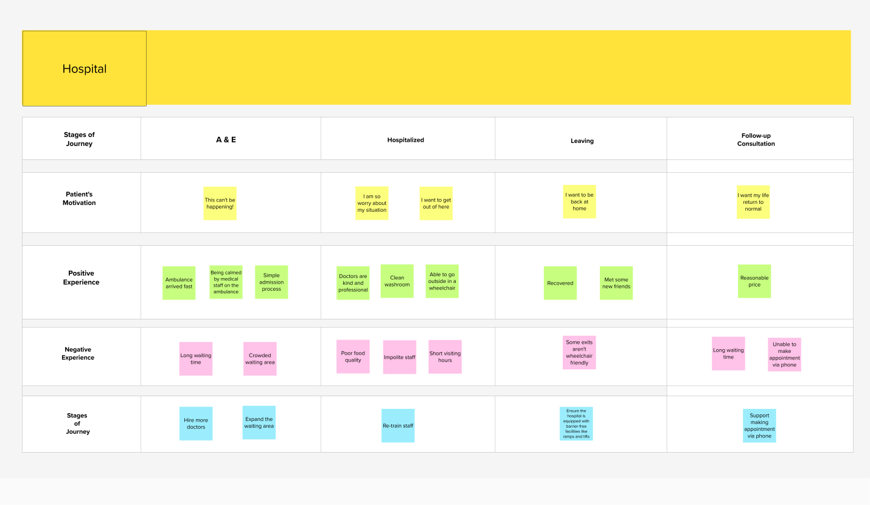

**Reference Link:**

[**https://app.mural.co/invitation/mural/krishnakannan8075/1665929273683?sender=u54d7632d013b879b07a77516&key=7e698784-e78b-4553-9545-22f4d521f1da**](https://app.mural.co/invitation/mural/krishnakannan8075/1665929273683?sender=u54d7632d013b879b07a77516&key=7e698784-e78b-4553-9545-22f4d521f1da)